# 

**Report for my semester project for MAP6014**

**Kalantarpour, Cyrus**

**Fall 2021**

[Company name] | [Company address]

2021

**Investigation of the relation between Human’s brain object recognition and its working memory using advanced EEG signal analysis and ML techniques**

I believe that Neuroscience and Artificial Intelligence have pushed each other forward. The concept of artificial neural networks (ANNs), which is inspired by the concept of biological neural networks, has undoubtedly altered AI history. When we look at the milestones of ANNs like convolution, long-term short memory, attention, learning algorithms, and so on, we can see how bio-thoughts influenced them. For this reason, I would like to use analysis the role of brain’s different parts communications in object recognition task.

In the following I tried to propose a few questions and answers to provide the reader with a better perspective.

What is the purpose of the work?

• A1: Discovering how humans brain memory interact with vision cortex.

• Q2: Which discipline and which themes are the choice of research topic?

• A2: Furrier Transform, Wavelet transform, Correlation analysis, Cross-frequency coherence analysis. Artificial Intelligence (AI), Machin-Learning (ML), Neural networks (NNs).

• Q3: Why the research topic is feasible?

• A3: There are lots of public EEG datasets and all the above methods are implemented in Python language.

• Q4: How do I compare my work with the other similar works?

• A4: Our comparison is quantitative, and the classification of processed EEGs will be compared by the accuracy measure.

• Q5: What is the research milestone(s)?

• A5: Put a step forward to understanding how different parts of the brain are communicating. It is worth noting that this information is very useful to improve computer vision neural networks.

• Q6: Why I decided to investigate human brain data?

• A6: I think Neuroscience and Artificial intelligence have pushed forward each other. It is obvious that history of AI has been revolutionized by the concept of artificial neural networks (ANNs) which is inspired by the concept of biological neural networks. If we look at the milestones of the ANNs such as, convolution, Long-term short memories, Attentions, learning algorithms and… we can see they have inspired by bio-thoughts.

• Q7: What is the type of my research?

• A7: It is an applied research.

• Q8: Which type of the methodology are I using in my research?

• A8: Quantitative.

• Q9: What data am I using in my research?

• A9: Public EEG datasets.

• Q10: What are the possible consequences of my research?

• A10: Improving the computer vision.

• Q11: What will be my future works?

• A11: Implementation of the inspired neural architecture.

# Introduction

We investigate the human brain electrical activity during a extensive brain stimulation during an sensory- cognitional task. More specifically, we investigate the human brains EEG signal while the clients are controlling a flight simulator. The intuition behind choosing of the aforementioned dataset is the ability of extracting the communication features of different human brain regions. That is because, during controlling of a flight simulator, most of the brains regions such as visual processor, audio processor, working memory, sensory motor (muscle control) and … should have an synchronized intercommunications and cross communications. As a result, this investigation may inform us how the human brain is able to use its different neural circuits to execute a complex task. It is worth noting that one of the main steps toward the Artificial General Intelligence is incorporation and integration of different types of neural architectures to overcome human- level task such as causal reasoning.

# EEG

The electroencephalogram (EEG) is a record of the oscillations of brain electric potential recorded from electrodes on the human scalp. Consider the following experiment. Place a pair of electrodes on someone's scalp and feed the unprocessed EEG signal to a computer display in an isolated location. Independently monitor the subject's state of consciousness and provide both this information and the EEG signal to an external observer. Even a naive observer, unfamiliar with EEG, will recognize that the voltage record during deep sleep has larger amplitudes and contains much more low-frequency content. In addition, the eyes closed waking) alpha state will be revealed as a widespread, near-sinusoidal oscillation repeating about 10 times per second (10 Hz). More sophisticated monitoring allows for accurate identification of distinct sleep stages, depth of anesthesia, seizures, and other neurological disorders. Other methods reveal robust EEG correlations with cognitive processes associated with mental calculations, working memory, and selective attention.

# Ten/20 coordinating system

The Ten/20 system is a measurement system that divides the human scalp into 19 sections and measures it. Each electrode of the EEG recording device will be positioned on one of these 19 locations in this arrangement. This system is in place. Pre-frontal (Fp), frontal (F), temporal (T), parietal (P), occipital (O), and central (C) are the names of the brain regions (C). The idea behind this brain partitioning is that distinct brain areas (Lobes) are important in different cognitive tasks. For example, visual processors are in the occipital lobes, working memory is in the temporal lobes, and auditory lobes are in the auditory lobe....

# 

Figure 1 Demonstration of the 10/20 measurement system. Each white circle shows an EEG electrode placement. The colored areas show different brain’s lobe.

# Artifacts

Electroencephalogram (EEG) technic helps healthcare professionals and researchers to detect and monitor brain activities and behavior. However, while monitoring brain activities, the artifacts which are non-brain activities such as blinking can interfere with the EEG procedure. Qi et al (2021) categorized common artefact components as blinking the eyes, horizontal or vertical eye movements, and generic discontinuities. More artifacts are categorized by Muscle movements artifacts such as: Respiration artifact –artifacts generated by talking and tongue movements and sweating.

Many algorithms and methods are developped for removing artefacts. However, there is no specific algorithm capable of removing all types of artifacts (Jiang, Bian, and Tian 2019).

Those contaminated EEG signal which prevent accurate EEG interpretation. There are two types of artifacts: – Nonphysiologic artifact (not from the patient) – Physiologic artifact (from the patient).

Regarding the nonphysiologic, possible sources could be: EEG device (Electrodes,  Headbox,  Amplifier,  Cable, Environment and...)

# Artifact rejection methods

There are two main technics for  Artifact rejection: 1)- Neural Networks such as [THE (Svoboda et al. 2016)]  2- statiscital methods (Nolan, Whelan, and Reilly 2010).

In the neural method usually use a convolution block and train the networks (Svoboda et al. 2016). Compared to the statisitcal method, neural method are more accurate but their accuracy may vary on different test sets[THE CONVOLUTION PAPER??]   In the following we see the some statistical artifacts rejection methods.

Fully Automated Statistical Thresholding for EEG artifact Rejection (FASTER), Independent component analysis (ICA) and wavlet ICA.

Compare to the ICA, FASTER is faster when applied to high-density EEG data. wavelet ICA

# Brains different regions’ cognitive function

According to the Johns Hopkins’ neurology department.

Frontal lobe. The largest lobe of the brain, located in the front of the head, the frontal lobe is involved in personality characteristics, decision-making and movement. Recognition of smell usually involves parts of the frontal lobe. The frontal lobe contains Broca’s area, which is associated with speech ability.

Parietal lobe. The middle part of the brain, the parietal lobe helps a person identify objects and understand spatial relationships (where one’s body is compared with objects around the person). The parietal lobe is also involved in interpreting pain and touch in the body. The parietal lobe houses Wernicke’s area, which helps the brain understand spoken language.

Occipital lobe. The occipital lobe is the back part of the brain that is involved with vision.

Temporal lobe. The sides of the brain, temporal lobes are involved in short-term memory, speech, musical rhythm and some degree of smell recognition.

# EEG data cross-correlation analysis

In this phase of this study, we wanted to test whether there are correlations between EEGs segments using cross-correlation technique.

The cross-correlation between two EEG channels measures the level of dependency between their frequency components. More specifically, If the cross-correlation of two EEG channels is 1 at a time $t0$, the EEGs are behaving similarly. That is, the amplitudes for the two channels are equal. Similarly, if the cross-correlation between two EEG channels is 0.8 at time $t1$, then the EEGs are behaving similarly at the $t1$ and the amplitudes of their components are 80% equal. Any negative correlation means the channels frequency components are correlated but their behavior is the opposite. Furthermore, the values around zero means EEG channels are acting independently (Dowdy, Wearden, & Chilko, 2011).

In the following we will illustrate all brain lobes intercommunications and communications in terms of the cross - correlation. Using the cross correlation will able us to discover the brain lobes communication harmonics and consequently their communication method which can help us improv e the existing artificial neural architectures.

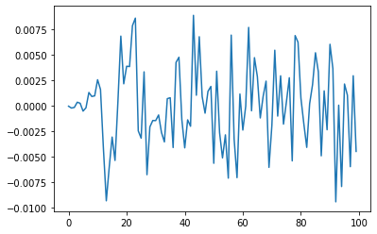

Figure 2:Pre-Frontal and Frontal lobe Cross -Correlation. The x axis is frequency and y axis the correlation value.

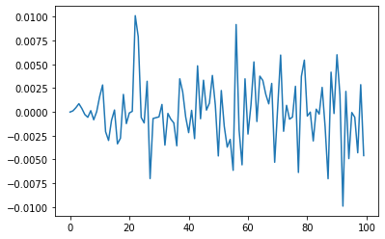

Figure 3 Pre-Frontal and Temporal lobe Cross -Correlation. The x axis is frequency and y axis the correlation value.

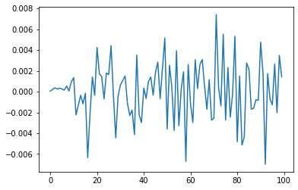

Figure 4 Pre-Frontal and Central lobe Cross -Correlation. The x axis is frequency and y axis the correlation value.

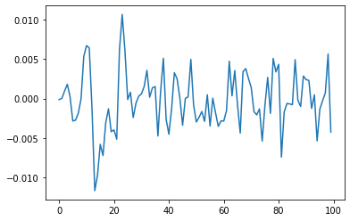

Figure 5 Pre-Frontal and Parietal lobe Cross -Correlation. The x axis is frequency and y axis the correlation value.

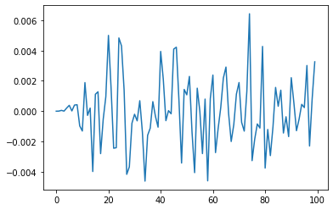

Figure 6 Pre-Frontal and Occipital lobe Cross -Correlation. The x axis is frequency and y axis the correlation value.

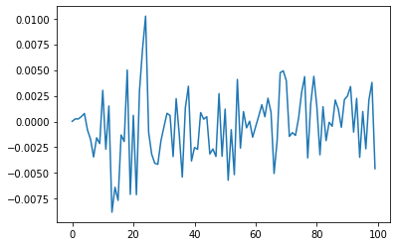

Figure 7 Frontal and Central lobe Cross -Correlation. The x axis is frequency and y axis the correlation value.

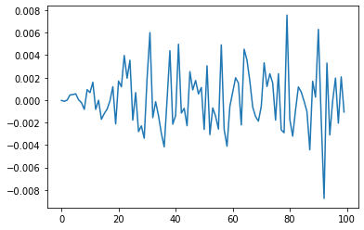

Figure 8 Frontal and Temporal lobe Cross -Correlation. The x axis is frequency and y axis the correlation value.

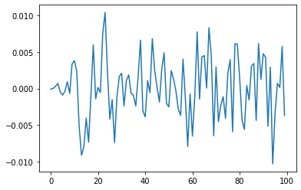

Figure 9 Frontal and Parietal lobe Cross -Correlation. The x axis is frequency and y axis the correlation value.

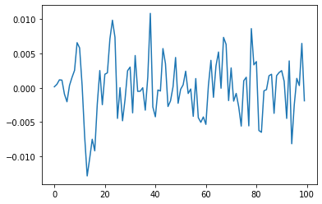

Figure 10 Frontal and Occipital lobe Cross -Correlation. The x axis is frequency and y axis the correlation value.

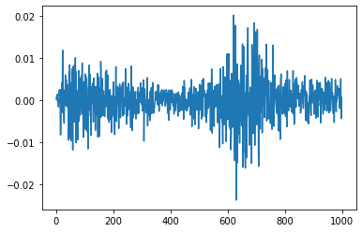

Figure 11 Total Cross correlation of the Pre-frontal and left occipital. The x axis is frequency and y axis the correlation value.

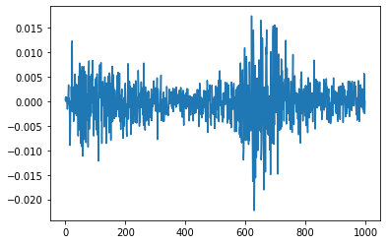

Figure 12 Total Cross correlation of the Pre-frontal and right occipital. The x axis is frequency and y axis the correlation value.

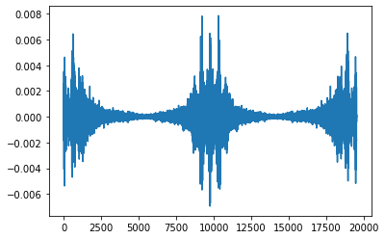

Figure 13 differentiation of Total Cross correlation of the Pre-frontal and left occipital with Pre-frontal and right occipital. The x axis is frequency and y axis the correlation value.

* **To see other cross- correlation please see the code.**

# Future works

My next step is feeding the Cross-Correlation data of the EEG channel to a Convolutional Autoencoder for feature extraction.

# Conclusion

We can see how different areas of the brain communicate in the diagrams above. The cross-correlation of the distinct lobes is difficult to interpret at first look (Figure 2-10). When we look at Figures 11–13, which show the entire cross correlations, we can see that several harmonics have emerged. Of course, we cannot determine how different brain lobes communicate, but the above data may be used to train a convolutional autoencoder (CAE), which is more instructive and informative. Since the CAE may extract a large number of features.

## References

1. Wardle, S.G. and C.I. Baker, *Recent advances in understanding object recognition in the human brain: deep neural networks, temporal dynamics, and context.* F1000Research, 2020. **9**.

2. Cichy, R.M. and D. Kaiser, *Deep neural networks as scientific models.* Trends in cognitive sciences, 2019. **23**(4): p. 305-317.

3. Khosla, M., G.H. Ngo, K. Jamison, A. Kuceyeski, and M.R. Sabuncu, *Cortical response to naturalistic stimuli is largely predictable with deep neural networks.* Science Advances, 2021. **7**(22): p. eabe7547.